Supporting community expression through media since 1998.

Board of Directors
Officers
Ryan VanLanduyt
President
Rice Lake Television

Jeff Robbins
Vice-President
Sun Prairie Media Center

John Kelly
Trempealeau County Community Television

Deb Brunett
Treasurer
Merrill Productions

Directors
Tina Breeze Wahlers
Janesville JATV

Jeremy Crosby
Fitchburg FACT

Gary Kaiser
Plymouth Community Television

Alan Luckett
Whitewater Community Television

Mike Ryan
West Bend Community TV

Breanna Speth
Marshfield Community Television

Derek Westby
WSTO Stoughton

Executive Director
Mary Cardona
Contact
(608) 215-5594
exec@
wisconsincommunitymedia.com

www.wisconsincommunitymedia.com

March 27, 2017

Mr. Jerry Deschane
Executive Director
League of Wisconsin Municipalities
131 West Wilson Street, Suite 505
Madison, WI 53703

Dear Jerry,

It is my pleasure to inform you that Wisconsin Community Media has chosen the Wisconsin League of Municipalities to receive the 2017 WCM Friend of Access Award in recognition of the league’s long-time support and groundbreaking collaboration that is bringing local issues to television through the league’s show, The Local Perspective.

The award reads, “In recognition of your contribution to the true democratic voice of the community – Public, Education, and Government Access Television.”

Wisconsin Community Media and the league have long been partners in support of community television or “PEG.” As local cable franchise authorities, local governments requested PEG access channels from cable companies in order for local governments, school districts, and the public to speak directly to members of the community. Cable company franchise fees (now called video provider fees) and, until 2011, dedicated PEG fees, financed these channels.

Our close collaboration began in 2006, when cities began to prepare to oppose potential state legislation that ultimately did move local cable franchising to the state level. LWM worked with Wisconsin Community Media and other allies to rid the legislation of provisions that would have irreparably damaged community television. While 2007 Act 42 contained language that sunset dedicated PEG fees, our efforts ensured that cities that wanted local PEG access channels would be able to continue to have them.

With cutbacks to and the demise of many local newspapers, coverage of local issues has declined, increasing the importance of local PEG television production facilities. Programs produced at these facilities not only appear on cable, but are also streamed on websites, social media platforms, and watched on-demand.

Last year, WCM and the League came together to devise a new way to collaborate to bring important local issues to people across the state. The Local Perspective series highlights the same issue that the magazine, The Municipality, has focused on that month. Utilizing the production facilities of WCM member stations from around the state, the league has brought its show to many different communities to interview local leaders and experts. WCM’s 53 member stations have been able to download the show from WCM’s digital archive for play around the state. WCM has truly enjoyed this collaboration.

For the February edition of The Municipality, the league invited WCM President Ryan VanLanduyt to write an article about community media. WCM appreciated this opportunity to talk to your members about what PEG media is doing today. We have also appreciated the notice we have received from the league via social media.

In closing, thank you for your continuing partnership that has led not only to saving local access television production facilities and channels but has also inspired your members to utilize PEG facilities more fully and our members to develop innovative collaborations across the state with new partners.

I look forward to greeting you and a guest or your designees at the Best of the Midwest Media Fest to be held on Thursday, April 6 at the Holiday Inn Milwaukee Riverfront. The Exhibitors Reception begins at 5:00 pm and the Banquet and Show begins at 6:30 pm. We will be presenting the League of Wisconsin Municipalities with the Friend of Access Award at the beginning of the show and invite you to say a few words. Please let me know who will be coming so we can make arrangements for you. Thanks!

Sincerely,
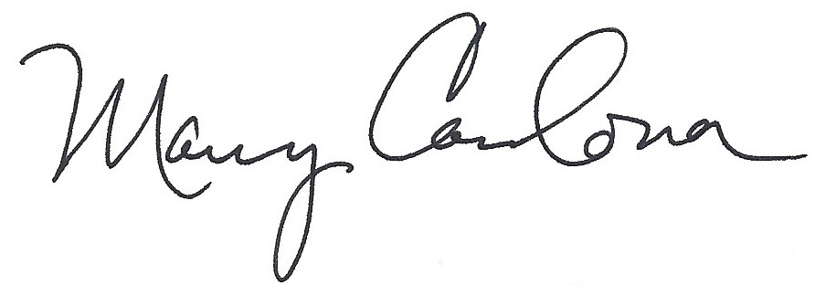
Mary Cardona
Executive Director

cc: WCM Members

